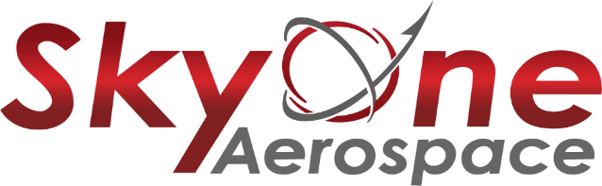www.skyoneaerospace.com
Inventory Control Clerk - Competitive wages and benefits, growing company, convenient Spokane Valley location.
SkyOne Aerospace is seeking a self-motivated Inventory Control Clerk to join our repair shop team who will be responsible for handling inventory tasks and working closely with the team and Materials manager to ensure parts and supplies are readily available to aid in the repairing of aircraft propeller components.
Primary Duties and Responsibilities:
- Responsible for pulling parts - working off work order numbers and system to accurately pull parts correctly and distribute to technicians and to correctly return any parts that were not needed back into inventory both physically and in computer system
- Maintains proper segregation and identification of parts and supplies
- Responsible for receiving in parts and shop supplies in – verifying packing slips and contents of shipments – keeping a correct and accurate inventory of all
- Performs cycle count of inventory – must be able to complete inventory count cycles to maintain an accurate inventory
- Outstanding ability to communicate - Interface and work closely with other colleagues daily as part of a team
- Properly documents all paperwork required for each transaction
Requirements and Qualifications:
- Knowledge of warehousing and inventory management
- Ability to communicate effectively in person, by phone and electronically
- Highschool diploma or equivalent required
- Verbal and written proficiency in the English language
- Must be a U.S. Citizen
- Basic Computer skills, must possess the ability to operate standard office equipment and pertinent software applications
- Knowledge is required to perform basic math - Ability to add subtract, multiply and divide in all units of measure, using whole numbers, common fractions, percent, and ratios.
- The Usual and customary methods of performing the functions of the job include meeting deadlines, keeping with schedules, setting priorities, and attention to detail
- Must have the physical ability to: lift, carry, push, pull; some climbing and balancing, frequent stooping, and standing.
- Must be able to understand and comply with SkyOne Aerospace Safety Policy and Accident Prevention Policy.
Candidate must comply with SkyOne Aerospace DOT Drug and Alcohol Policy.
Compensation $17 - $19 DOE - Full Time Monday through Friday 7am to 3:30pm
If you have the experience we are looking for and a desire to take part in this exciting opportunity please send a resume to Sales@skyoneaerospace.com or employment@skyoneaerospace.com

Pre-employment background testing and drug screen
DOT regulated random drug and alcohol testing

